Step 1: at the top right of your screen click on the dropdown button on the left of your “account” dropdown button, take note of your selected region.

Step 2: in your search bar search and select “EC2” amazon services.

Step 3: at the left sidebar, click on “Network & Security” dropdown button and select “Security Groups” to create two Security Groups, one for Website and another for Database. Click on “Create security group” and name as “MyWebApp” and “MyDatabase”.

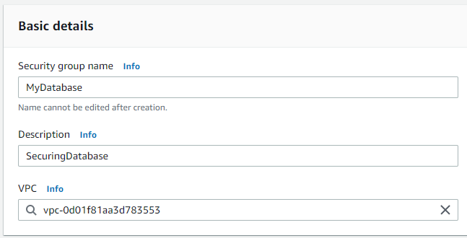

(MyWebApp)

(MyDatabase)

Step 4: at the left sidebar, click on “Instances” dropdown button and select “Instances” to create two instances, one for Website and another for Database. Click on “Launch instances” and name the two servers as “MyWebApp” and “MyDatabase”.

1. “MyWebApp” Server
   1. Select “Windows Microsoft” as your Amazon Machine Image Operating System
   2. Under Key pair (login) select “Create new key pair”. Key pair name as “MyKeyPairs”, file format as ‘.pem’.

1. “MyDatabase” Server

Step 5: